The instruction for authors – the title of the paper
(TNR 13pt bold, 70pt spacing before and 15pt spacing after the last line)
(First Author) Name Surname (TNR 11pt italic), Institution
(Second Author) Name Surname (TNR 11pt italic), Institution
(Third Author) Name Surname (TNR 11pt italic), Institution
(TNR 12pt)
(TNR 12pt)
(TNR 12pt)
Abstract: This instruction provides directions for editing The Collection of Papers from of Academy of Applied Technical Studies Belgrade – Department of Traffic, Mechanical and Protective Engineering. The authors are to edit their papers in technical manner, following the instructions of this manual. The abstract should not contain more than 200 words, using the font TNR 12pt in italics. It should be written in one or more paragraphs, with alignment left and right (Justify), using the Serbian Latin keyboard layout.
The abstract cannot contain tables, graphs, drawings and photos, nor citations from other authors.

Keywords: first keyword, second keyword (maximum of 5 – TNR 12pt)

TITLE OF THE PAPER IN ENGLISH
(TNR 13pt bold, 30pt spacing before and 15pt spacing after last line)
Abstract: Translate the abstract with up to 200 words in English.
Keywords: translate keywords into English.
(TNR 12pt)

INTRODUCTION (The title of the chapter – TNR 12pt BOLD)
(TNR 12pt)
The complete paper (text, drawings, photographs, using author’s full name with affiliations), written in Microsoft Word, font TNR, Serbian Latin keyboard layout, should be sent to: radovi@skupsaobracaj.atssb.edu.rs. The maximum length of the paper for The Collection of Papers (including drawings, photographs, tables, literature, attachments and etc.) is limited to (6) pages in A4 size.
(TNR 12pt)

TEXT FORMATING AND WRITTING.
(TNR 12pt)
  - Text writing (The sub-chapter title – TNR 12pt BOLD)
(TNR 12pt)
All four margins in the paper should be indented by 2 cm. The text should be typed in Serbian (Serbian Latin) or in English, TNR font (Times New Roman) 12pt using single spacing (1), with alignment left and right (Justify). The space between paragraphs should be 12pt (blank line). Pages should not be marked with numbers. Abbreviations and acronyms must be defined with the first appearance in text, regardless of their definition in the abstract. Commonly known abbreviations such as MKS, SI, TV, etc. do not need to be defined.

  - Expressions writing, tables and figure adjustments
(TNR 12pt)
Equations are to be prepared with Word’s Equation Editor or by Math Type. Parameters for equation typing are: font TNR, 12pt; the size of subscripts and superscripts is 10pt, the size of sub-subscripts is 8pt. Numbers, parentheses and capital Greek symbols are to be written normally (not italic), as well as operators and functions. All Latin type variables A, B, X, Y, a, b, x, y, as well as small Greek symbols α, β, γ, should be written in italic, and the vector and matric symbols Γ, A, X, are to be written in TNR Bold.

Formulas are cited in angular parentheses, e.g. (1) and should be marked with a number to the right edge of the text.
$\left(\frac{a}{b}\right) ,lnln \left(x\right),max,min,f\left(x\right)$ (1)

Figures and diagrams are to be centred. The text in figures and diagrams must be readable, therefore font TNR size 9 or 10pt should be used. Every figure/diagram to is to be marked with a number below, with the addition of short name (description), with previous reference in the text. Be sure to specify the source below the image / diagram. If the source is a website, then the link needs to be shortened (use a short link).

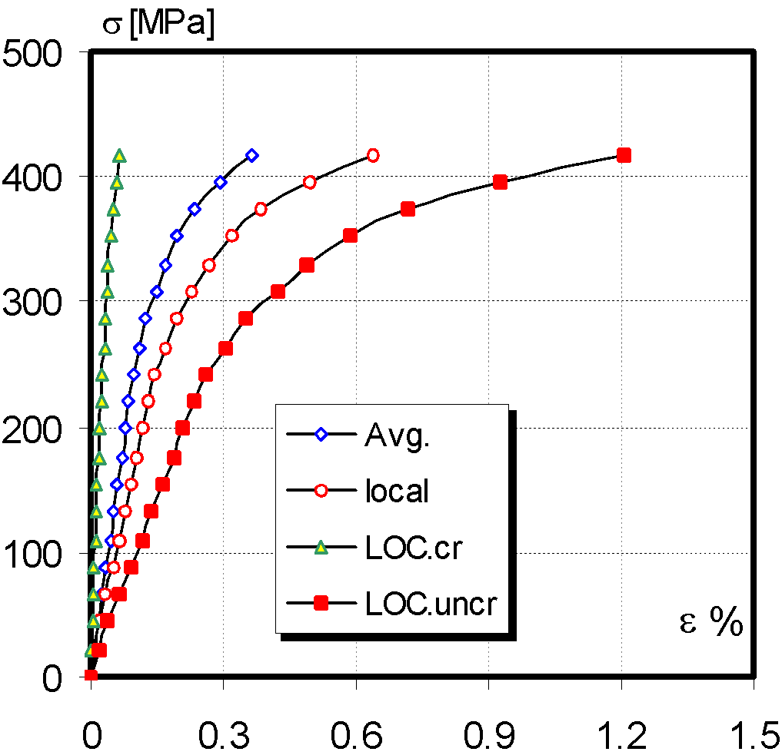
Figure 1. The Dependence of voltage-deformation TP1 (TNR 12 pt)
Source:specify the image source (TNR 10 pt)

Figures should be submitted as separate files, using TIF or JPEG format in case of additional editing (this especially applies to photos), or in PDF format (if they were done in CorelDraw or one of the programs from the Adobe Package).

Tables should be centred. The size of tables and the text in them need to be readable, therefore the text should be written in TNR font 12pt. and centred in table columns. A number and a short name (the source of the table should be indicated in brackets) is to be added above each table, with the previous reference to the table in the text. If the source is a website, then the link needs to be shortened (use a short link).

Table example:

Table 1. Geometrical data (mm) (TNR 12pt)
Source:specify the data source (TNR 10pt, italic)
 |  |  | Velika- Large | Mala- Small
Površinska prslina | Surface crack |  | LSC | SSC
Dubina prsline | Crack depth | a | 2.5 | 1
Dužina prsline | Crack length | 2c | 8 | 8
Vrh prsline | Crack tip | r | 0.1 | 0.1
Dužina MŠ | WM length |  | 2 | 2

- CONCLUSION
(TNR 12pt)
Papers written in an inadequate form will be returned for additional editing. The original as-received document may be additionally formatted (editors’ choice).
(TNR 12pt)

LITERATURE
(TNR 12pt)
Literature should be specified at the end of the paper, in a special, non-numerical part. References in the text should be cited alphabetically, using square breakers, for example: Author’s surname, first letter of the name, the year of publication (TNR, small letters 11pt), and in continuation, the full title of the paper, the name of the journal or other source, the volume and number of the journal, pagination. When making references, the numbers in brackets should be written within a sentence e.g. [3] or at the end of the sentence e.g. [4,5,6].

Examples of referencing literature:

[1] Surname, N., Surname, N.: Name of Book (in Italics), Publisher, ISBN, Place of Publication, (YYYY)
[2] Surname, N. &Surname, I.: Name of paper or Chapter, In Name of Book (in Italics), Publisher, ISBN, Place of Publication, (YYYY), pp. xxx-yyy
[3] Surname, N.; Surname, N. &Surname, N.: Title of conference paper, Proceedings of xxx xxx, Surname, N. (Ed.), pp. xxx-yyy, ISBN, conference location, Month and Year, Publisher, City, (YYYY)
[4] Surname, N.: Name of Paper, Name of Journal (in Italics), Vol. (YYYY) No., pp. xxx-yyy, ISSN

The example of referencing web pages:

[1] Narodna Banka Srbije, 2014. Vlasnička struktura i bilans stanja/uspeha banaka. [Internet] Available on: http://www.nbs.rs/internet/cirilica/50/50_5.html (Accessed: 01.05.2019.)

NOTE:
THE AUTHORS ARE IN OBLIGATION TO PROVIDE A SIGNED STATEMENT ON THE COPYRIGHT OWNERSHIP AND THE ORIGINALITY OF THE MANUSCRIPTS (filled in electronically or scanned document)

First author email (TNR 10pt)
Second author email (TNR 10pt)
Third author email (TNR 10pt)

